**Project Development Phase**

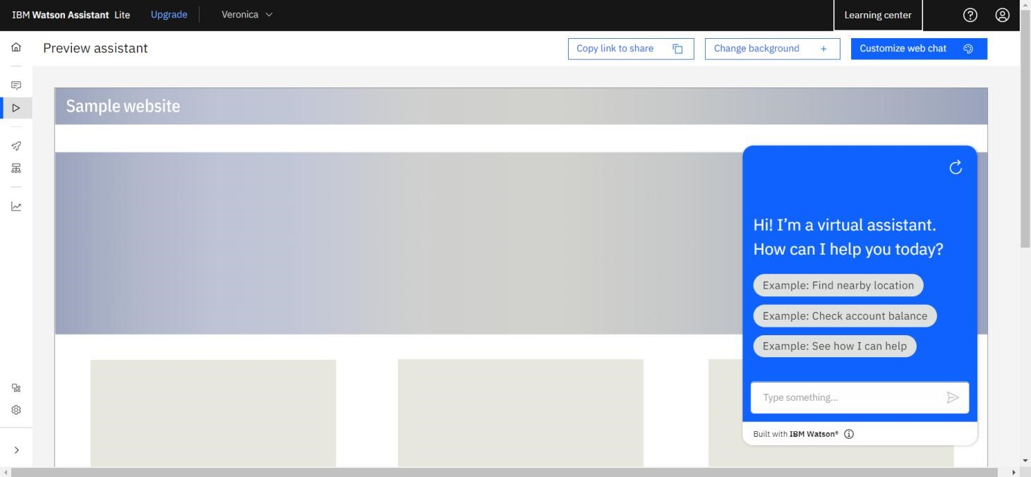**Delivery of Sprint - 1**

|  |  |
| --- | --- |
| **Date** | 07 November 2022 |
| **Team ID** | PNT2022TMID10041 |
| **Project Name** | AI based discourse for Banking Industry |

# Creating IBM Watson Service

In this activity, we are creating the necessary IBM Watson Service.

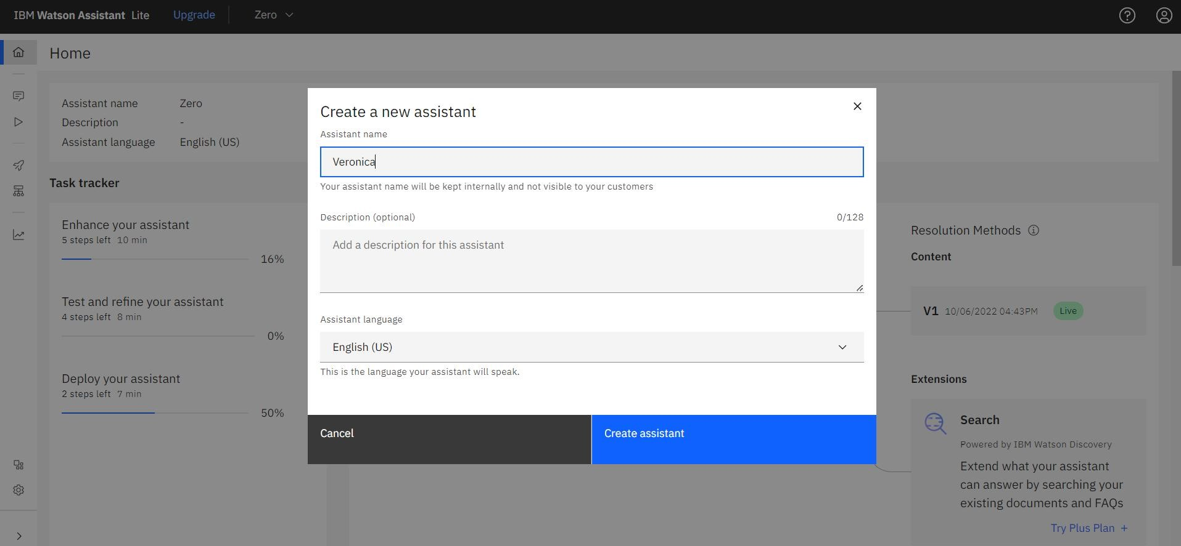

# Creating ActionSkills

Skillsare nothingbut actions and steps. Stepsare the subset ofactions whereconversationsare builtandtheassistantis integrated with theseskills.

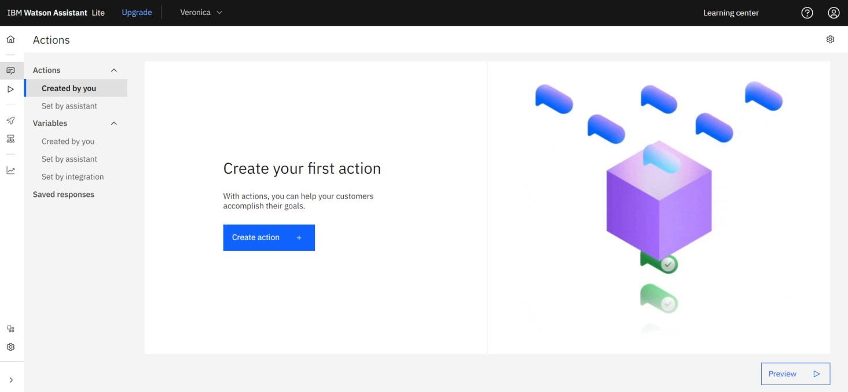

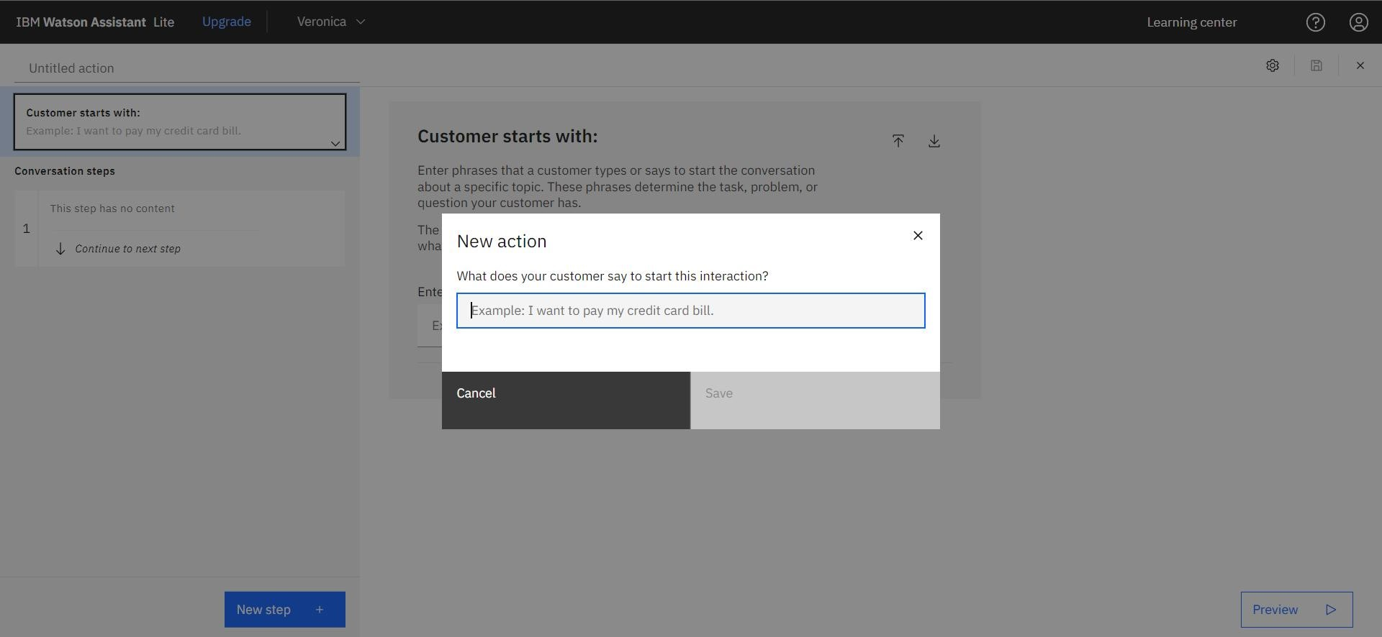

# Creating Savings Action

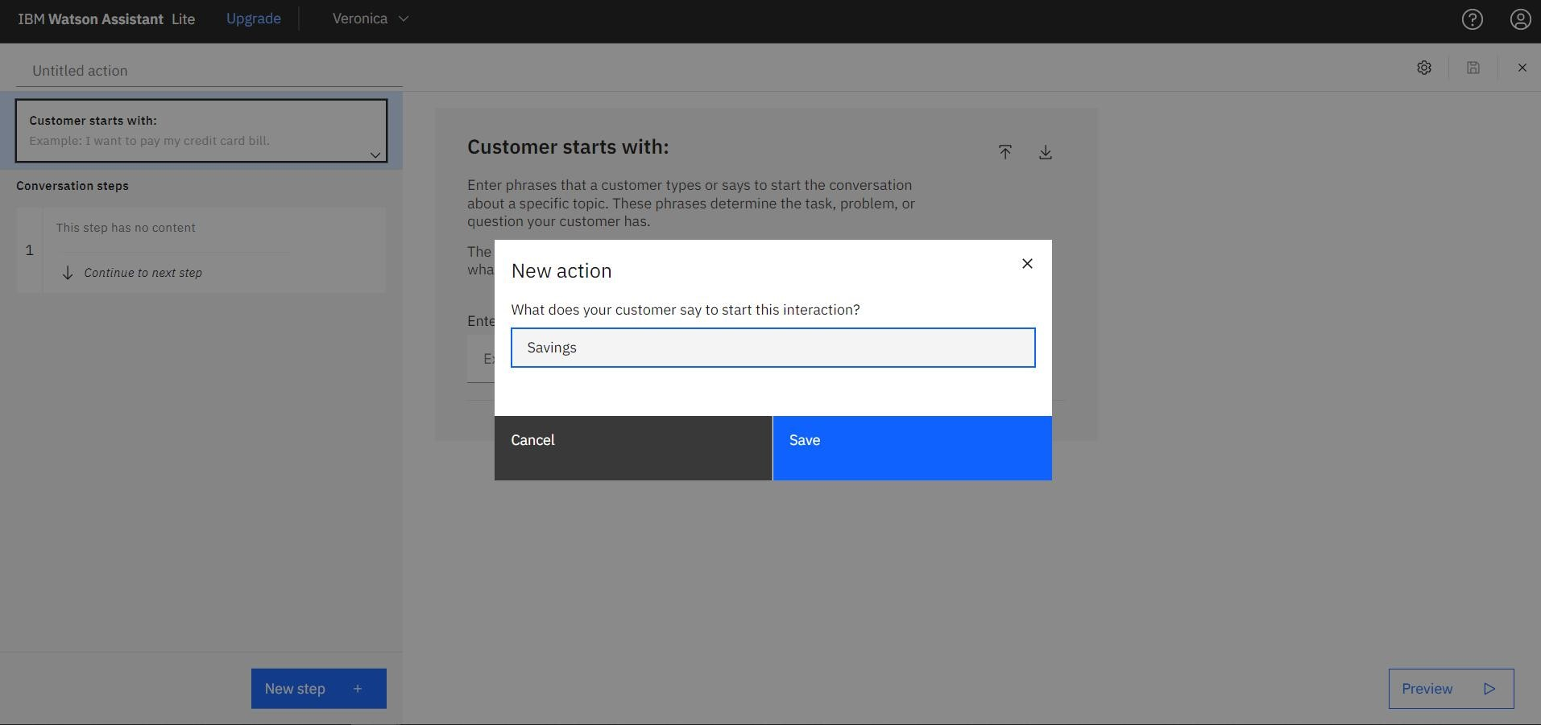

In this step, we are adding steps in Savings Action to handle customer queries regarding Regular Savings Account, Kids Savings Account and Zero - Balance Account creation.